**PRACTICAL-2**

**AIM:**

An organization works on IT projects. It has mainly 3 departments i.e. php, .net and android. CEO of that organization wants to configure a single network but virtually divided into 3 department in such a way that the packets can travel or broadcasted within the same department only. Demonstrate the configuration of such network in cisco packet tracer.

**THEORY:**

**Switch**

* Switches are networking devices operating at layer 2 or a data link layer of the OSI model.
* They connect devices in a network and use packet switching to send, receive or forward data packets or data frames over the network.
* A switch has many ports, to which computers are plugged in.
* When a data frame arrives at any port of a network switch, it examines the destination address, performs necessary checks and sends the frame to the corresponding device
* It supports unicast, multicast as well as broadcast communications.
* Switches are active devices, equipped with network software and network management capabilities
* Switches can perform some error checking before forwarding data to the destined port.

**VLAN**

* **VLAN** is a custom network which is created from one or more local area networks.
* It enables a group of devices available in multiple networks to be combined into one logical network.
* The result becomes a virtual LAN that is administered like a physical LAN. The full form of VLAN is defined as Virtual Local Area Network.
* VLAN in networking is a virtual extension of LAN

**PRACTICAL IMPLEMENTATION:**

* In this practical, we will use switch as we have to divide only one network and there is no need of other network.
* Then, we will take some PCs which will act as different hosts for different departments.

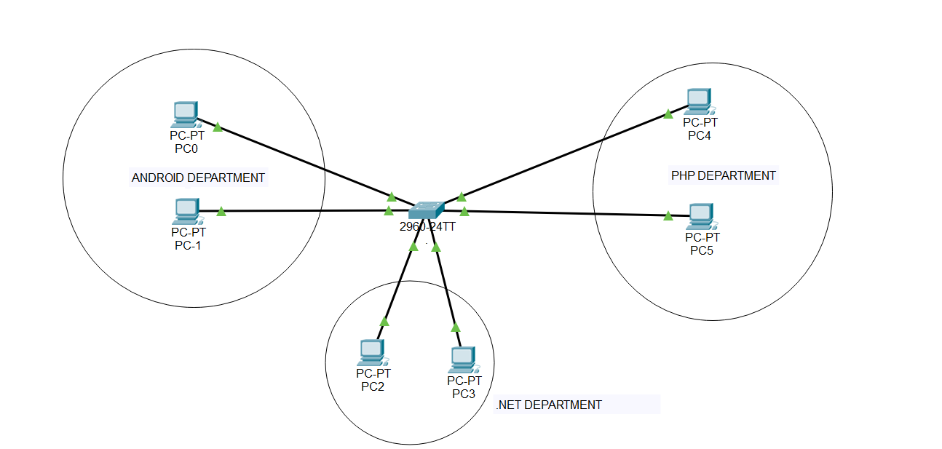

* Now, Assign IP Address to each and every PC.
* To assign IP Address, DESKTOP >> IP CONFIGURATION

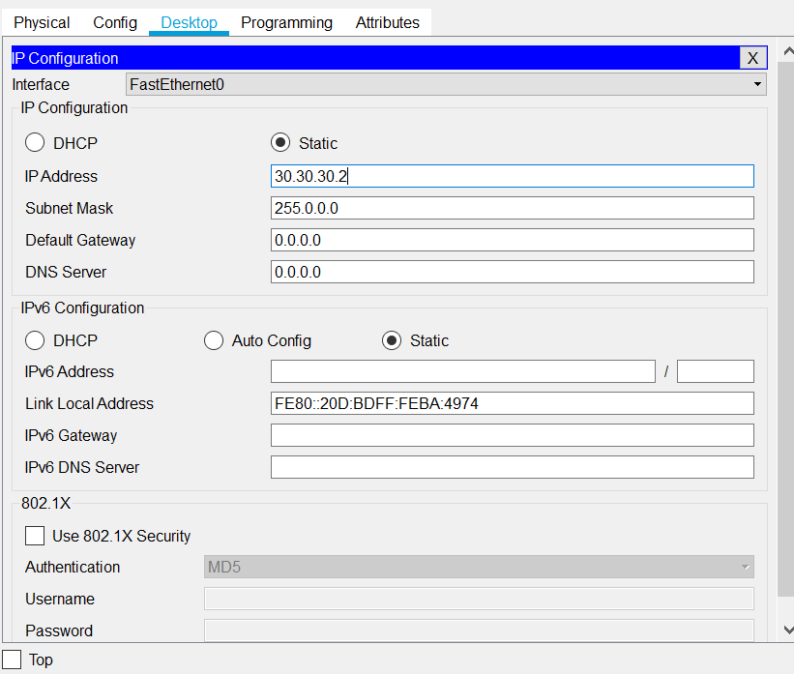

* Repeat same steps for all the PCs.
* Give different IP address to PCs in different network
* To know the details regarding the VLAN, open the CLI in switch and type “show vlan”.

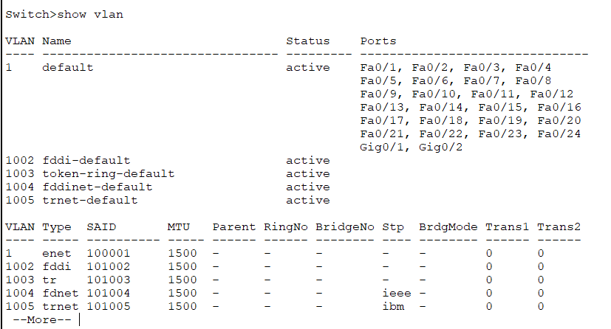

* By default all the ports are in one vlan.
* To create three vlans, first, go to privilege mode by typing “enable”.
* Enter in configuration mode.
* Write vlan and its ID.
* To give it a name type “ name vlan_name”
* Type “exit”

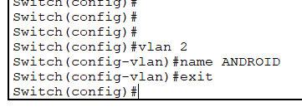

* Perform the same steps for another two vlans

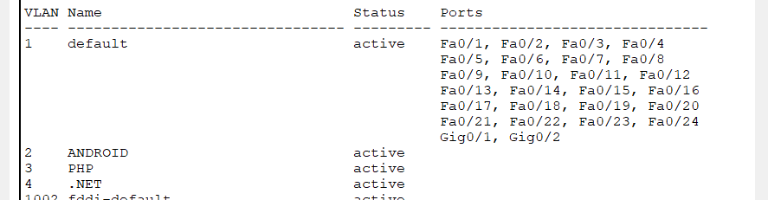

* We will assign the ports to each newly created vlan
* Again go to configuration mode
* Then, go to interface fastEthernet0/1
* Type, switchport access vlan 2
* Exit from the interface
* Repeat same steps for other 2 vlans

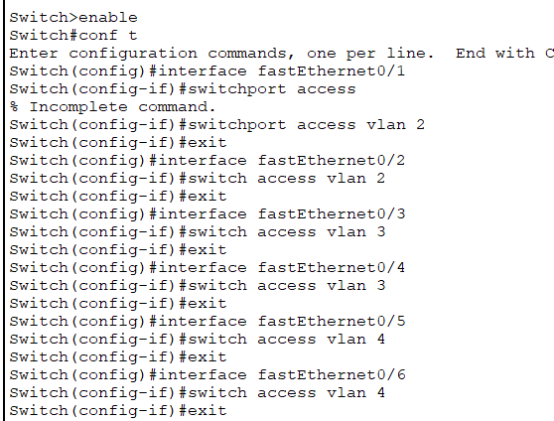

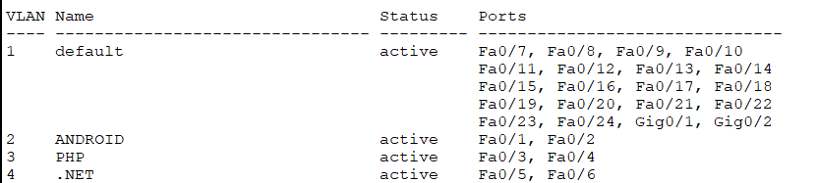

**CHECKING THE VLAN:**

1. Ping Test:

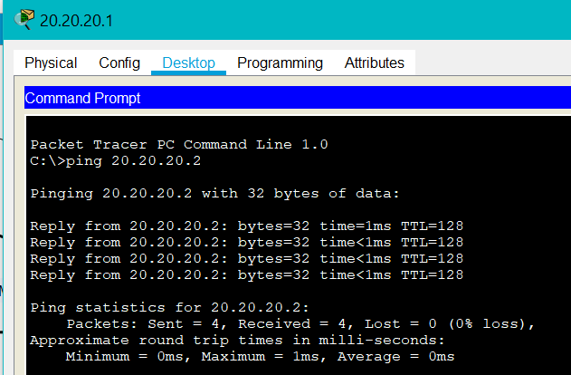

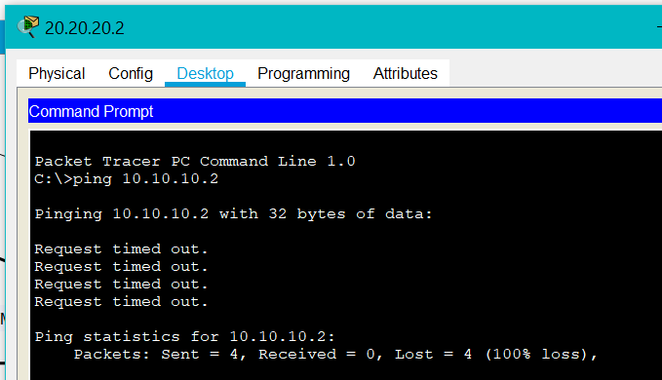

We cannot communicate to devices outside the network.

**CONCLUSION**:

* By performing the practical, we learnt about vlan and how to configure it.